August 2008
Issue 7
Safety Matters

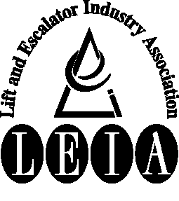
Articles:

• CSCS

• Industry Accident Statistics

• Accident Awareness

- Asbestos

Tel: 020 7935 3013
Fax: 020 7935 3321
Email: enquiries@leia.co.uk
Welcome to the August 2008 edition of Safety Matters.
Through this newsletter our aim is to inform you of health and safety issues in the lift & escalator industry however we would welcome from LEIA members examples of good practice and suggestions for future issues. If there are any topics you would like to see included in future editions please contact T Potter on the above number or email at terry.potter@leia.co.uk
This Safety Matters is also on the LEIA website. www.leia.co.uk

Introduction

CSCS

The LEIA member accident statistics covering 2007 have been published and show an increase over those occurring in 2006

Sadly in 2007 a member reported a fatal accident, which is still under investigation.

The number of major accidents increased by 50% from 8 to 12.

The number of smaller injuries where the person was off work for 3 or more days increased also from 110 to 115.

Overall with all the above accident numbers combined it resulted in an increase to the Accident Incident Rate (AIR) where there was 2.09 persons injured per 100 employees as opposed to 1.87 in 2006.

The most frequently occurring causes of accident were manual handling and slips, trips and falls.

A reminder that many CSCS card holders within the lift and escalator industry will be approaching the renewal date of their cards.

Those employees who attained their card through the Industry Accreditation route (grandfathers rights) do run the risk of losing the card if it is not renewed on time.

Card holders going through the renewal process will have to sit the health and safety test – a book containing the questions and answers is obtainable through the CITB publications or popular book stores such as WH Smiths. It is worth investing in the book as many of the questions have been updated.

If you require further information contact LEIA or go to the CSCS website at www.cscs.uk.com

Since the touch screen test was introduced in December 2003 3750 lift/escalator tests have been sat achieving an 85% pass rate, second highest of all groups participating in the CSCS Scheme.

Industry Accident Statistics

Accident Awareness

As the lift was returned to service the fitter dropped an object into the shaft and made the decision to retrieve it without following the correct safety procedures. He entered the pit, retrieved the object and as he was leaving the pit he was caught by the toe guard of the lift.

As the landing door lock roller had not been set up correctly at this time and was sticking into the shaft, the skate activated the lock therefore stopping the lift and allowing another call to be placed.

The fitter called out and the mate placed a call from the upper landing to make the lift travel in the up direction which allowed the fitter to be removed from the shaft.

DIRECT CAUSE

- A screwdriver was used to bridge the landing door lock.
- Fitter did not follow safe pit access procedure.

ROOT CAUSES

- Fitter did not adhere to company safety rules and procedures

RECOMMENDATIONS
- Communicate the details of this serious near hit to industry.

WHAT HAPPENED
A fitter had entered the lift pit to retrieve an object. As he was leaving the pit he was caught between the toe guard and landing cill.

INVESTIGATION
The work was to carry out repairs to shutter doors and replace a lock.

Work had been completed with the exception of setting up the ground floor landing lock.

The mate working with the fitter was clearing up the tools. He got off the top of the car and informed the fitter that the lift had been returned to normal operation. The fitter confirmed he understood that this was the case. The mate then closed the landing doors and the lift homed to the ground floor.

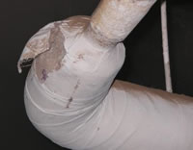
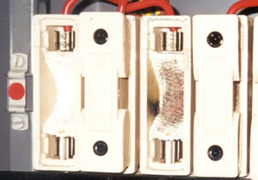
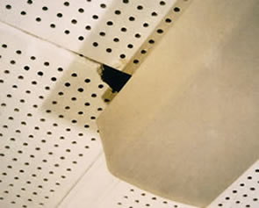
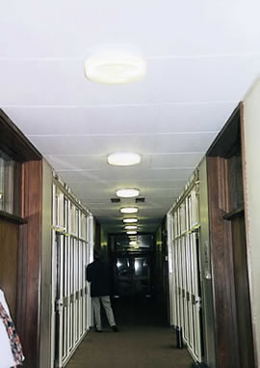
FACTS

It is estimated by the HSE that each week 20 tradesmen die as a result of exposure to asbestos.

Any building built or refurbished before the year 2000 could contain asbestos.

Every year there are still 4000 deaths from asbestos related diseases.

It is thought that the number of fatalities will peak in 2010 to 2015 due to the time it takes the disease to develop.

There is no cure.

If any material is thought to be asbestos or might contain asbestos then the procedures laid down by your company must be followed. This is for your own safety and future health.

Asbestos

The pictures show examples of where Asbestos may be found in buildings. It might also be found in older lift equipment particularly in brake linings, within entrances, arc shields and fire stops in trunking. If ever in doubt get advice from your company.

